Department of Computer Science and Engineering
The University of Texas at Arlington

Team: Ink3D
Project: 3-D Printer Fabrication System
Team Members:
Daniel Lain
Timothy Edmonson
Shawn Simonson
Jesse Bowles

Last Updated: 9/23/2013 7:11 pm

Table of Contents
Table of Contents 2
Document Revision History 5
List of Figures 6
List of Tables 7
1. Product Concept 8
1.1 Purpose and Use 8
1.2 Intended Audience 8
2. Product Description and Functional Overview 9
2.1 Features and Functions 9
2.2 External Inputs and Outputs 10
2.3 Product Interfaces 14
3. Customer Requirements 16
3.1 STL File Input 16
3.2 Graphical User Interface 16
3.3 Generate Machine Instructions 16
3.4 Issue Machine Instructions 17
3.5 Monitor Temperature 17
3.6 Monitor Position 17
3.7 Adhere to Material Constraints 18
3.8 Identify Materials 18
3.9 Identify Shapes 18
3.10 Determine Shape of Support Material Structure 19
3.11 Create Printing Path 19
3.12 Database Interface 19
3.13 Store & Load Material Records 19
3.14 Slice Geometry into Thickness Levels 20
3.15 Monitor Flow Sensors 20
3.16 Monitor Door Switch 20
3.17 Allow for UV Head Polymerization 21
3.18 Fill Density 21
3.19 Graphical Object Models 21
4. Packaging Requirements 22
4.1 Software Installer 22
4.2 Host Software to Printer Connection 22
4.3 User Manual 22
5. Performance Requirements 23
5.1 Startup Time 23
5.2 STL Import Time 23
5.3 Object Processing Time 23
5.4 GUI Responsiveness 24
5.5 Real Time Sensor Monitoring 24
6. Safety Requirements 25
6.1 Temperature Cutoff Threshold 25
6.2 Printing Area Restrictions 25
7. Maintenance and Support Requirements 26
7.1 Host Software Manual 26
7.2 Source Code Documentation 26
7.3 Source Code Availability 26
8. Other Requirements 28
8.1 Material Database 28
8.2 Abstract Hardware Interface 28
8.3 Modular and Scalable Design 28
9. Acceptance Criteria 29
9.1 Verify that the system reads STL files 29
9.2 Verify the database interface 29
9.3 Verify the system prints a model 29
9.4 Verify the system stops printing of out of operational range 30
10. Use Cases 30
10.1 Import STL File to System 30
10.2 Print 3D Object 30
10.3 Edit Material Database 31
10.4 Edit Printer Configuration 31
11. Feasibility Assessment 33
11.1 Scope Analysis 33
11.2 Research 34
11.3 Technical Analysis 35
11.4 Cost Analysis 36
11.5 Resource Analysis 37
11.6 Schedule Analysis 37
11.6.1 Size Estimate – Function Points 37
11.6.2 Effort Estimate – Jones First Order Estimation 40
11.6.3 Size Estimate – Lines of Code 40
11.6.4 Effort Estimate – CoCoMo 41
11.6.5 Effort Estimate – Estimate Comparison 41
12. Future Items 42
12.1 Customer Requirement 3.17 – Monitor Door Switch 42
12.2 Customer Requirement 3.19 – Fill Density 42
12.3 Customer Requirement 3.20 – Graphical Object Models 42

Document Revision History
Revision Number | Revision Date | Description | Rationale
0.1 | 9/23/13 | Initial
0.2 | 11/3/13 | Modify Requirements | Peer and Mr. O’Dell Review
1.0 | 11/3/13 | Gate Review Version | Final changes prior to gate review
2.0 | 11/18/13 | Baseline | Changes based on gate review feedback

List of Figures
Figure # Title Page #
1-1 System Components 7
2-1 System Concept 11
2-2 Example Images (Stents, Bone Scaffolds) 11
2-3 3D Printing Interface 14
2-4 Material Data Interface 14
10-1 Use Case: 3D Printer Operations 32

List of Tables
Figure # Title Page #
2.2 External Inputs and Outputs 11
11.1 Cost Analysis Table 35
11.2 Function Points Analysis 36
11.3 Influence Multipliers 38
11.4 Jones First Order Estimation 39
11.5 Size Estimate – Lines of Code 39
11.6 CoCoMo Estimate 40
11.7 Estimate Comparison 40

1. Product Concept
This section describes the purpose, use and intended audience for the 3-D Printer Fabrication System product. The printer will allow items to be produced using an additive material process. The 3-D Printer Fabrication System will produce items consisting of more than one material of possibly very different characteristics.

Purpose and Use
The 3-D Printer Fabrication System will provide an interface for converting standard stereo lithography or STL files into realized items. The system will use a simple graphical user interface to select the files and materials to be used in the production of the 3D model. When a file is loaded, the system will translate the STL file in to a series of layers based on the granularity of the materials to be used in the final build. The system will then use the layers to produce a series of paths for the print head to traverse to deposit the correct material to the specified location. From this series of steps, an instruction set will be produced for the printer to execute each path for every layer and material. Finally, the instructions will be issued to the printer and it will execute the commands producing the designed object that was described by the original STL files.

Intended Audience
The intended audience of the 3-D Printer Fabrication System is the research and medical fields. The initial device will be for Dr. Panos S. Shiakolas, Manufacturing Automation and Robotic Systems (MARS) lab at University of Texas Arlington, who will be testing the unit with human compatible materials with the intent of making medical implements such as stents, personalized plates for use in bone repair, dental implants, or bone supplants.

Figure 1-1 System Components

2. Product Description and Functional Overview
This section describes the functions of the 3-D Printer Fabrication System. The primary operational aspects of the product, from the perspective of end users, maintainers, and administrators are defined here. The key features and functions found in the 3-D Printer Fabrication System, as well as critical interactions and user interfaces are described in detail.

2.1 Features and Functions
The 3-D Printer Fabrication System contains a platform that is the base where the desired object is printed. Above the platform, an arm with multiple nozzles can move about the xyz axis and extrude the material that makes up the object. The 3-D Printer Fabrication System begins by accepting an STL file(s) that contains the description of the object the user desires to be printed. After selecting the type of material(s) wanted for the object, the user confirms that the object is ready to be printed. The 3-D Printer Fabrication System reads the STL file(s) and slices the described object into layers to formulate a path for each material. The 3-D Printer Fabrication System then calibrates the nozzle to the correct settings for the first material and begins printing the first layer. After a single material has been printed for that layer, the printer switches to the next material to be printed until finished with that layer. The 3-D Printer Fabrication System then formulates new paths for the next layer and starts the printing process again. This continues until the last layer is finished.
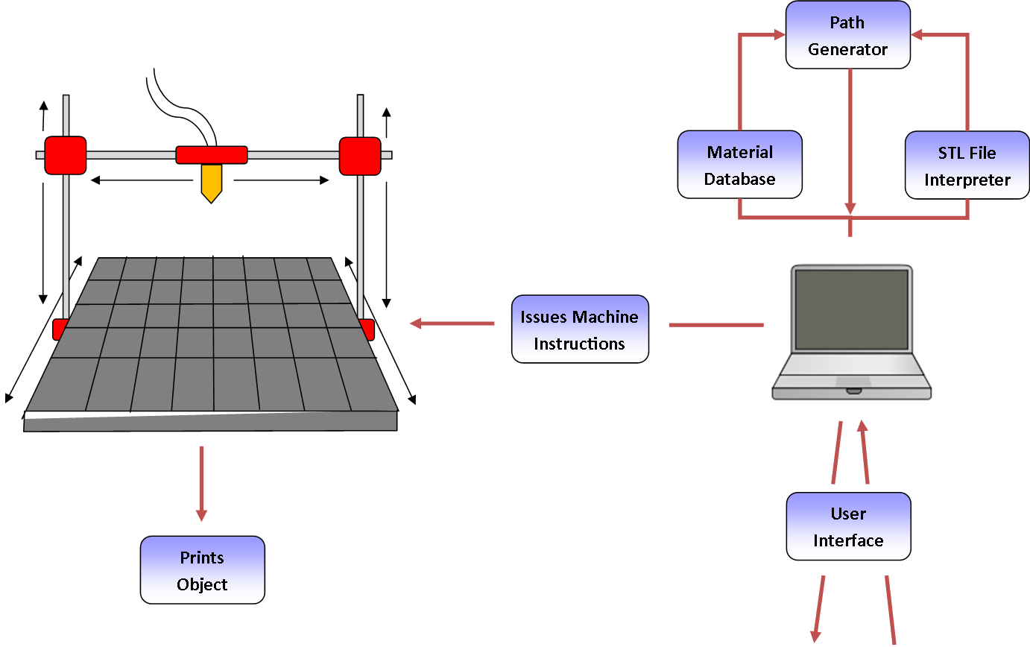
Figure 2-1: System Concept
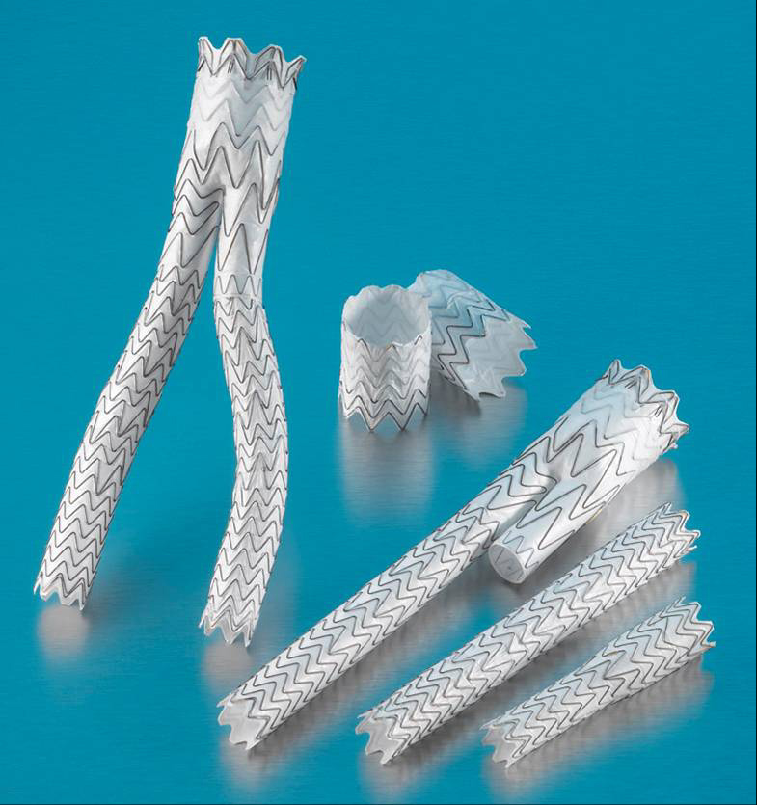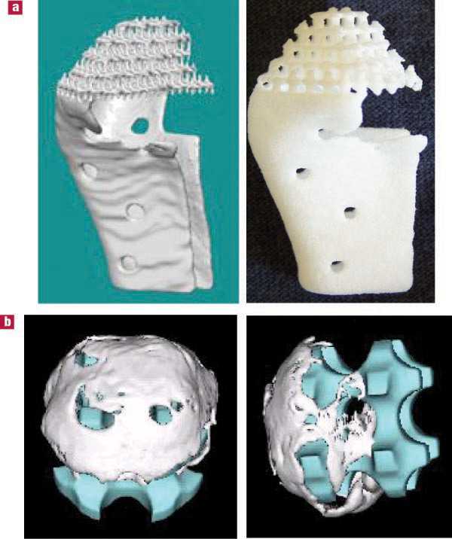
Figure 2-2: Example Images (Stents, Bone Scaffolds)

2.2 External Inputs and Outputs
The 3-D Printer Fabrication System will take several inputs when a user begins the printing process. The model will be imported using a common industry format such as STL or AMF. The 3-D Printer Fabrication System will need to read in several variables such as heat, position, and state. Below is a detailed listing of all inputs and outputs.
Type: | Name: | Description: | Use:
Input: | STL File | A file format used to store data about a 3D model. | The system will process this file to determine what the shape of the object we are printing is.
Input: | Material Data | Contains information necessary for printing with each material such as extrusion speed, temperature it should extrude at, and speed at which the nozzle can move while extruding. | The system stores this information in a small database and retrieves the info when it is ready to use that material. The material data is imperative for printing that material properly.
Input: | Selection | All the settings and options that must be defined before the printing can be done (e.g. material type, how many objects will be printed at once) | The system at minimum will require a user to select an STL file of an object the user wants printed.
Input: | Start Printing | An interface option to begin printing. | The user presses this button after initializing what will be printed and the correct parameters for the material being used are in place.
Input: | Stop/Pause Printing | An interface option to end or pause printing after printing has started. | An option to halt printing can be useful in case of errors that are occurring that are not being caught by the system or if the user no longer desires the object to be printed.
Input: | Heat Sensor | A temperature gauge that monitors the temperature of the nozzle. | Each material being extruded for the print has a target temperature it must be at in order to print properly. The system needs sensors to verify that the temperature is correct, and make corrections to the heating when it is not.
Input: | Position Sensor | A sensor that tracks the position of the arm and nozzle. | The system needs a way to track the position of the nozzle and arm so that it can carry out the printing paths correctly.
Input: | Flow Sensor | A sensor that tracks how fast the material is extruding from the nozzle. | Each material requires a target flow speed in order to print properly with that material. The system uses the flow sensor to verify that the speed of flow is correct, and makes corrections when it is not.
Input: | Door Sensor | A sensor that tracks when the door is open or closed. | If the system uses a closed environment, the system would benefit from knowing when the environment is secure (closed door) or not (door is opened).
Output: | G-Code | Formal codes that control the printer. | Stream to printer to print objects.
Output: | State Notification | A notification that lets the user know the state of the 3-D Printer Fabrication System. | Ensure the user knows the current state of the device.
Output: | Confirmation Message(s) | Any potential notification that the user should receive before the system begins printing the object. | The system should verify that what it is about to print is what the user wants. Proper verification can prevent wasting material and printing time.
Output: | Printed Object | The physical 3D object that is created by the system. | The system's primary goal is to print this object.

2.3 Product Interfaces
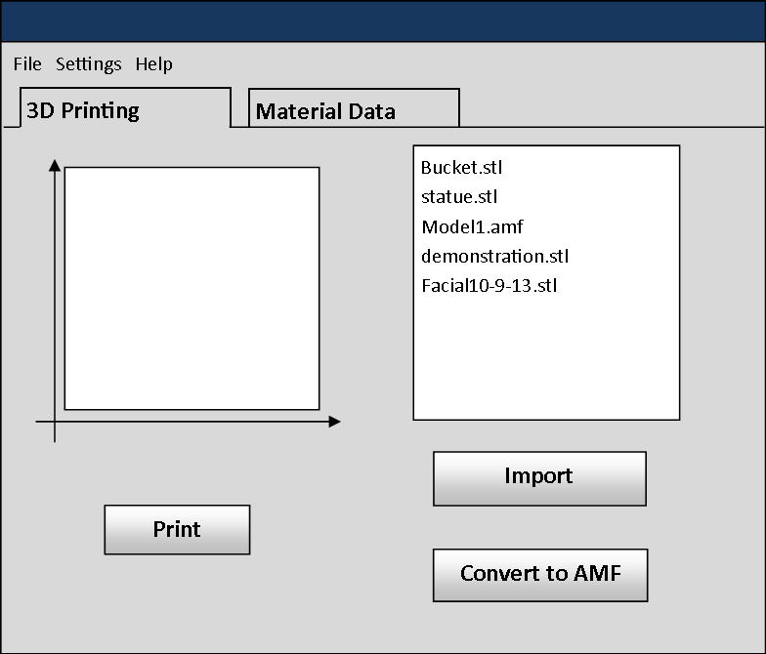
Figure 2-2: 3D Printing Interface
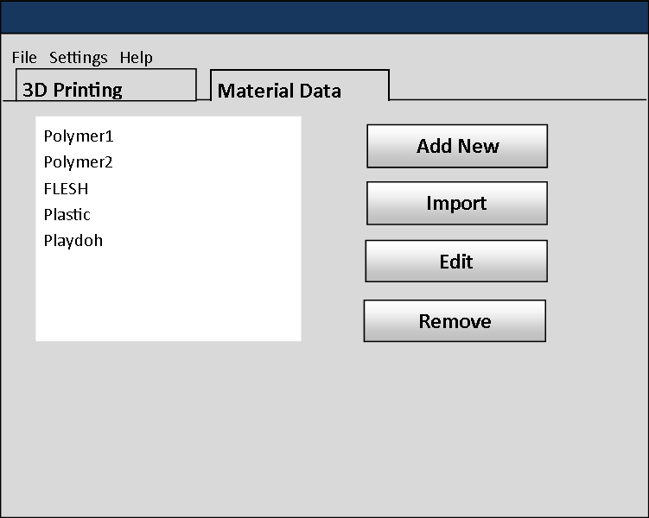
Figure 2-3: Material Data Interface

3. Customer Requirements
This section specifies the requirements provided by Dr. Shiakolas, the project’s sponsor, and the intended audience of the 3-D Printer Fabrication System. The requirements in this section must be implemented in order for the product to function the way Dr. Shiakolas intends. The requirements in this section shall not be altered without the approval of Dr. Shiakolas and the members of the development team. These requirements deal with the user interface of the system as well as the functionality expected by the product’s audience.

3.1 STL File Input
3.1.1 Description: The system shall provide a way for the user to select an STL file and then input that STL file into the system for processing.
3.1.2 Source: Dr. Panos S. Shiakolas (Sponsor)
3.1.3 Constraints: The system must support multi-material objects but the STL file format does not support material information. Model must be closed / complete.
3.1.4 Standards: STL (STereo Lithography) File Format
3.1.5 Priority: 1 - Critical

3.2 Graphical User Interface
3.2.1 Description: The system shall provide a graphical user interface from which the user can import 3D models and initiate print operations. The GUI must be both intuitive and responsive.
3.2.2 Source: Dr. Panos S. Shiakolas (Sponsor)
3.2.3 Constraints: None
3.2.4 Standards: Java Swing/AWT
3.2.5 Priority: 3 - Moderate

3.3 Generate Machine Instructions
3.3.1 Description: The system shall generate instructions needed by the printing hardware in order to print a given 3D object.
3.3.2 Source: Dr. Panos S. Shiakolas (Sponsor)
3.3.3 Constraints: The machine instruction set is currently undefined.
3.3.4 Standards: STL, AMF, GCode
3.3.5 Priority: 1 – Critical

3.4 Issue Machine Instructions
3.4.1 Description: The system shall issue generated machine instructions from the software component to the printing hardware component.
3.4.2 Source: Dr. Panos S. Shiakolas (Sponsor)
3.4.3 Constraints: None
3.4.4 Standards: GCode
3.4.5 Priority: 1 – Critical

3.5 Monitor Temperature
3.5.1 Description: The system shall monitor input from heat sensors attached to the printing hardware. The temperature of each extruder’s nozzle must be monitored at all times to ensure that material is extruded at the proper temperature.
3.5.2 Source: Dr. Panos S. Shiakolas (Sponsor)
3.5.3 Constraints: In order to monitor the temperature of different extruder nozzles, the printing hardware must output information describing the temperature of each extruder nozzle.
3.5.4 Standards: None
3.5.5 Priority: 1 – Critical

3.6 Monitor Position
3.6.1 Description: The system shall monitor the position of the printing head at all times during operation. The system must be aware of the position of the printing head in order to adhere to a predefined printing path.
3.6.2 Source: Dr. Panos S. Shiakolas (Sponsor)
3.6.3 Constraints: In order for the printing head position to be monitored by the system, the printing hardware must output information describing the position of the printing head.
3.6.4 Standards: None
3.6.5 Priority: 1 – Critical

3.7 Adhere to Material Constraints
3.7.1 Description: The system shall adhere to the material constraints that limit the movement speed, extrusion rate, and nozzle temperature. Different materials have different properties that the system must account for in order to produce a properly printed object.
3.7.2 Source: Dr. Panos S. Shiakolas (Sponsor)
3.7.3 Constraints: The Mechanical Engineering team must provide Information about the constraints for each material before our team can input them into the system.
3.7.4 Standards: None
3.7.5 Priority: 1 - Critical

3.8 Identify Materials
3.8.1 Description: The system shall provide a method for the user to select the material for each discrete part that is being used for printing the 3D object.
3.8.2 Source: Dr. Panos S. Shiakolas (Sponsor)
3.8.3 Constraints: None
3.8.4 Standards: STL
3.8.5 Priority: 1 - Critical

3.9 Identify Shapes
3.9.1 Description: The system shall identify the shape of the object being printed by dividing it into smaller shapes for each individual material used.
3.9.2 Source: Dr. Panos S. Shiakolas (Sponsor)
3.9.3 Constraints: Unification of multiple shapes within the same dimensional space.
3.9.4 Standards: STL file
3.9.5 Priority: 1 - Critical

3.10 Determine Shape of Support Material Structure
3.10.1 Description: The system shall determine the shape that the support material needs to be for stabilizing the 3D object as it is being printed. Without the support, the object could collapse during printing.
3.10.2 Source: Dr. Panos S. Shiakolas (Sponsor)
3.10.3 Constraints: Complex analytical geometry.
3.10.4 Standards: None
3.10.5 Priority: 1 - Critical

3.11 Create Printing Path
3.11.1 Description: The system shall determine a route that the printing head must follow as it prints.
3.11.2 Source: Dr. Panos S. Shiakolas (Sponsor)
3.11.3 Constraints: Cannot print two materials on the same path.
3.11.4 Standards: G-Code
3.11.5 Priority: 1 - Critical

3.12 Database Interface
3.12.1 Description: The system shall have an interface that allows the user to view what material is already stored in the database and enter new information for material not already stored.
3.12.2 Source: Dr. Panos S. Shiakolas (Sponsor)
3.12.3 Constraints: None
3.12.4 Standards: Java / Swing / AWT
3.12.5 Priority: 1 - Critical

3.13 Store & Load Material Records
3.13.1 Description: The system shall be able to load the material records stored in the materials database in order to control the temperature, movement speed, and flow speed of the nozzle at the correct setting.
3.13.2 Source: Dr. Panos S. Shiakolas (Sponsor)
3.13.3 Constraints: None
3.13.4 Standards: Must be able to be serialized.
3.13.5 Priority: 1 – Critical

3.14 Slice Geometry into Thickness Levels
3.14.1 Description: The system shall be able to process geometry in such a way as to generate sub-models of appropriate and customizable thickness such that the 3D printer can print each layer of the given thickness.
3.14.2 Source: Dr. Panos S. Shiakolas (Sponsor)
3.14.3 Constraints: None
3.14.4 Standards: None
3.14.5 Priority: 1 – Critical

3.15 Monitor Flow Sensors
3.15.1 Description: The system shall monitor nozzle flow sensors and be able to maintain and adjust accordingly if the sensor begins to read out of bounds.
3.15.2 Source: Dr. Panos S. Shiakolas (Sponsor)
3.15.3 Constraints: None
3.15.4 Standards: None
3.15.5 Priority: 1 – Critical

3.16 Monitor Door Switch
3.16.1 Description: The system shall be able to use a sensor to monitor the 3D printer’s access door. Appropriate action should be taken when the door is opened during printing and ensure the door is closed prior to starting to print.
3.16.2 Source: Shawn Simonson (Team Member)
3.16.3 Constraints: None
3.16.4 Standards: None
3.16.5 Priority: 5 – Future

3.17 Allow for UV Head Polymerization
3.17.1 Description: The head shall be able to use UV light to cure or dry the extruded material. The system shall accommodate the use of UV to be turned on and off such that the material can be cured.
3.17.2 Source: Dr. Panos S. Shiakolas (Sponsor)
3.17.3 Constraints: The system shall allow for duplicate paths.
3.17.4 Standards: None
3.17.5 Priority: 1 – Critical

3.18 Fill Density
3.18.1 Description: The system shall allow for models to be processed in such a way that the geometry can be simplified or made more complex according to user specifications from any arbitrary model geometry. Such that the density of the path generated will provide a porous structure instead of a solid structure. This will allow the user to prototype a design without wasting large amounts of material or time.
3.18.2 Source: Dr. Panos S. Shiakolas (Sponsor)
3.18.3 Constraints: Processing/Memory complexity.
3.18.4 Standards: None
3.18.5 Priority: 5 – Future

3.19 Graphical Object Models
3.19.1 Description: The system shall display a graphical model of the objects represented by imported STL files. The user will be able to drag the graphical model around on a virtual printer bed in order to specify the location on the printer bed where the object will be printed.
3.19.2 Source: Dr. Panos S. Shiakolas (Sponsor)
3.19.3 Constraints: This will require graphics processing and may make the GUI unresponsive.
3.19.4 Standards: None
3.19.5 Priority: 5 – Future

4. Packaging Requirements
This section describes the delivery and packaging of the 3-D Printer Fabrication System to the end-user. The software and hardware components of the system each have separate delivery and packing requirements. This document specifies the software system requirements; therefore this section specifies the software delivery and packaging requirements as well as the delivery and packaging requirements for the physical interface between the software and hardware.

4.1 Software Installer
4.1.1 Description: The host software shall be delivered as an executable installer via USB flash memory and Compact Disc.
4.1.2 Source: Dan Lain (Team Member)
4.1.3 Constraints: None
4.1.4 Standards: Windows Installer
4.1.5 Priority: 1 – Critical

4.2 Host Software to Printer Connection
4.2.1 Description: The host software shall be connected to the printing hardware using a DE-9, DB-25, or Universal Serial Bus cable.
4.2.2 Source: Shawn Simonson (Team Member)
4.2.3 Constraints: None
4.2.4 Standards: USB, RS-232
4.2.5 Priority: 1 – Critical

4.3 User Manual
4.3.1 Description: The system shall be delivered with a user manual. The user manual will include detailed instructions on how to operate the host software and how to properly connect the host software to the printer.
4.3.2 Source: Tim Edmondson (Team Member)
4.3.3 Constraints: None
4.3.4 Standards: None
4.3.5 Priority: 3 - Moderate

5. Performance Requirements
This section describes the performance requirements for the product. The system is required to be responsive to user interaction, process 3D models efficiently, and monitor sensors in real time.

5.1 Startup Time
5.1.1 Description: The host software shall start in one minute or less.
5.1.2 Source: Tim Edmondson (Team Member)
5.1.3 Constraints: None
5.1.4 Standards: None
5.1.5 Priority: 4 – Low

5.2 STL Import Time
5.2.1 Description: The host software shall import STL files in one minute or less.
5.2.2 Source: Tim Edmondson (Team Member)
5.2.3 Constraints: Model must be closed / complete.
5.2.4 Standards: The STL file format will be imported.
5.2.5 Priority: 4 – Low

5.3 Object Processing Time
5.3.1 Description: The host software shall perform object processing and machine instruction generation in five minute or less.
5.3.2 Source: Tim Edmondson (Team Member)
5.3.3 Constraints: The geometric processing algorithms used to process objects must be efficient. The complexity and size of the object can significantly affect the time required to process it. Model must be closed / complete.
5.3.4 Standards: None
5.3.5 Priority: 4 – Low

5.4 GUI Responsiveness
5.4.1 Description: The graphical components of the user interface shall be responsive to user interaction.
5.4.2 Source: Tim Edmondson (Team Member)
5.4.3 Constraints: In order to achieve a responsive user interface, multi-thread processing may be required.
5.4.4 Standards: None
5.4.5 Priority: 3 – Moderate

5.5 Real Time Sensor Monitoring
5.5.1 Description: The system shall monitor data from sensors in real time during operation. The sensor data must be monitored in real time to ensure proper printer functionality as well as enforce safety systems.
5.5.2 Source: Tim Edmondson (Team Member)
5.5.3 Constraints: Constant monitoring of sensors could require expensive processing and memory resources.
5.5.4 Standards: None
5.5.5 Priority: 2 – High

6. Safety Requirements
This section specifies the requirements concerned with ensuring that the product functions in a safe manner. 3D printers extrude material at very high temperatures, which causes safety concerns. These safety concerns are addressed by the following requirements.

6.1 Temperature Cutoff Threshold
6.1.1 Description: The system shall include a temperature cutoff threshold for the printer head. If the temperature of the printer head reaches the cutoff temperature, the system will abort the operation and shut off the heating device.
6.1.2 Source: Tim Edmondson (Team Member)
6.1.3 Constraints: The system must be able to accurately monitor the temperature of each printing head.
6.1.4 Standards: None
6.1.5 Priority: 1 – Critical

6.2 Printing Area Restrictions
6.2.1 Description: The system shall only extrude material within a configured area. Material extruded by the printer will be at a high temperature and may cause harm to the printer’s surroundings; therefore it is important to ensure that the material is only extruded in a specified safe area.
6.2.2 Source: Tim Edmondson (Team Member)
6.2.3 Constraints: None
6.2.4 Standards: None
6.2.5 Priority: 1 – Critical

7. Maintenance and Support Requirements
The primary components identified for support are the host software and the hardware used for 3D printer. All support to be provided is in the form of documentation of the three components.

7.1 Host Software Manual
7.1.1 Description: A manual that details the operation of the host software shall be provided. Here, “host software” is that software which is run on the workstation that generates machine instructions for the printing hardware. The manual must detail common troubleshooting issues as well as provide basic usage instructions.
7.1.2 Source: Shawn Simonson (Team Member)
7.1.3 Constraints: None
7.1.4 Standards: None
7.1.5 Priority: 1 – Critical

7.2 Source Code Documentation
7.2.1 Description: The source code developed by the software team shall be well documented with comments explaining the functionality of all modules and any non-obvious code. This documentation is intended to support any future development on the system.
7.2.2 Source: Tim Edmondson (Team Member)
7.2.3 Constraints: None
7.2.4 Standards: None
7.2.5 Priority: 2 – High

7.3 Source Code Availability
7.3.1 Description: The source code developed by the software team shall be freely available to developers and the public. The source code will be hosted on a public repository.
7.3.2 Source: Shawn Simonson (Team Members)
7.3.3 Constraints: None
7.3.4 Standards: Git, SVN
7.3.5 Priority: 2 – High

8. Other Requirements
This section describes requirements that did not fit within the requirements sections above. These requirements deal with data management and modularity.

8.1 Material Database
8.1.1 Description: The system shall have a database that holds information about how the material is printed. For each material, the database must hold the diameter of the material filament, the temperature the filament must be extruded at, the extrusion speed, and weather a secondary head option such as UV curing light is required.
8.1.2 Source: Dr. Panos S. Shiakolas (Sponsor)
8.1.3 Constraints: None
8.1.4 Standards: Binary Text
8.1.5 Priority: 1 – Critical

8.2 Abstract Hardware Interface
8.2.1 Description: The system shall allow for multiple different printers and multiple different heads to be used with minimal software change.
8.2.2 Source: Jesse Bowles (Team Member)
8.2.3 Constraints: Unknown hardware interface
8.2.4 Standards: None
8.2.5 Priority: 1 – Critical

8.3 Modular and Scalable Design
8.3.1 Description: The software shall be developed using proven design principles to ensure that it can be scaled and maintained by future development teams. This design will allow the future requirements such as the Door Sensor to be implemented without difficulty.
8.3.2 Source: Dr. Panos S. Shiakolas (Sponsor)
8.3.3 Constraints: None
8.3.4 Standards: S.O.L.I.D. Design Principles
8.3.5 Priority: 1 – Critical

9. Acceptance Criteria
These acceptance criteria will be tested during the verification testing of the 3-D Printer Fabrication System project. The following are critical points in the functional success of the 3-D Printer Fabrication System project.

9.1 Verify that the system reads STL files
9.1.1 Requirement(s) addressed: 3.1 – STL File Input
9.1.2 Verification Procedure: The user will be able to see the file has been accepted and the file name will be displayed in the GUI.

9.2 Verify the database interface
9.2.1 Requirement(s) addressed: 3.2 – Graphical User Interface, 3.13 – Database Interface, 3.14 – Store and Load Material Records, 8.1 – Material Database
9.2.2 Verification Procedure: The user will load the GUI and click on the view/edit database button. The user then will see and be able to edit stored values. Upon changing values the user will return to the main menu. Clicking on the view/edit button again will display the edited values.

9.3 Verify the system prints a model
9.3.1 Requirement(s) addressed: 3.1 – STL File Input, 3.3 – Generate Machine Instructions, 3.4 – Issue Machine Instructions, 3.6 – Monitor Temperature, 3.7 – Monitor Position, 3.8 – Identify Material Constraints, 3.9 – Identify Materials, 3.10 – Identify Shapes, 3.11 – Determine Shape of Support Material Structure, 3.12 – Create Printing Path, 3.14 – Store and Load Material Records, 3.15 – Slice Geometry into Thickness Levels, 3.16 – Monitor Flow Sensors, 4.2 – Host Software to Printer Connection
9.3.2 Verification Procedure: The user will load an STL file and click print. The system will then print the correct shape and material.

9.4 Verify the system stops printing of out of operational range
9.4.1 Requirement(s) addressed: 6.1 – Temperature cutoff threshold, 3.16 – Monitor Flow Sensors
9.4.2 Verification Procedure: During a print run a fan will be pointed at the head reducing its temperature to below specified material requirements and the printer will stop printing until the temperature is raised to the correct level.

10. Use Cases
The Use Cases below show the interactions between the user and the system. The 3D Printer Fabrication System can accomplish several tasks that give the user control of generating physical 3D objects. The system allows the user to import STL files that the user wants printed. If the object is made of a material that is not known to the system, the user can update the system manually and add material entries to the system’s database. Finally, when the user is ready, the user can request the system to print the object modeled from the STL file.

10.1 Import STL File to System
10.1.1 Scenario: The user selects an STL file to be printed.
10.1.2 Actor(s): The user
10.1.3 TUCBW: The user clicks the “Import STL” button
10.1.4 TUCEW: The user sees the confirmation message that STL file was successfully uploaded.

10.2 Print 3D Object
10.2.1 Scenario: The user uses the system to print an STL file as a physical 3D object.
10.2.2 Actor(s): The user
10.2.3 TUCBW: The user clicks the print button.
10.2.4 TUCEW: The user sees the physical 3D object on the platform.

10.3 Edit Material Database
10.3.1 Scenario: The user can add new or modify material information in the database.
10.3.2 Actor(s): The user
10.3.3 TUCBW: The user clicks the “Update Materials” button.
10.3.4 TUCEW: The user sees the material updated in the database.

10.4 Edit Printer Configuration
10.3.1 Scenario: The user can add new or modify existing configuration details for the specific printer used.
10.3.2 Actor(s): The user
10.3.3 TUCBW: The user clicks the “Update Configuration” button.
10.3.4 TUCEW: The user sees the updated specification in the database.

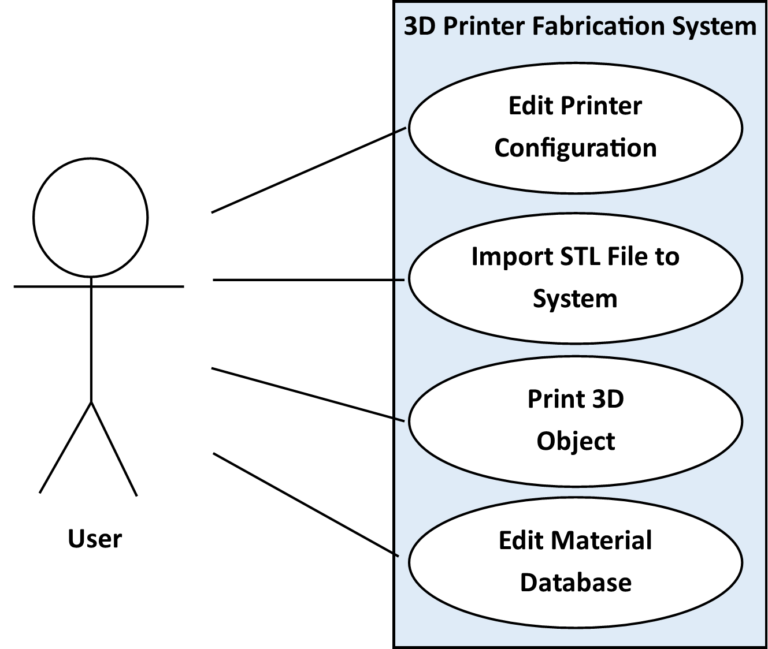
Figure 10-1 Use Case: 3D Printer Operations

11. Feasibility Assessment
This section will go into depth of the feasibility of this project. Based on the team’s scope analysis, research, technical analysis, and cost analysis, the team concludes that this project is feasible. Team Ink3D does not have prior experience with creating or programming a printer, so this assessment is based on the team’s discussions with the sponsor as well as the team’s current research in 3D printing technologies.

11.1 Scope Analysis
The 3D Printer Fabrication System Project is split up between two teams. The Mechanical Engineering Team is in charge of developing the physical printing machine, while Team Ink3D is in charge of the developing the software that sends the printer G-Code instructions and any necessary firmware modifications. Team Ink3D is not responsible for providing sensors for the system but is responsible for utilizing those sensors. In addition, Team Ink3D must control the extruder motor and the location of the nozzle.
Due to the nature of the 3D Printer Fabrication System, there are many critical requirements that must be met in order for the system to perform its main function. Team Ink3d believes that the system has 19 critical requirements that are essential to the system. Of the 19 critical requirements, four of the critical requirements should be easy and quick to implement because of our experience with interfaces and small databases. These are the client interface, the material database, the database interface, and the storing and loading of material records. The bulk of the work will come from taking the read STL file and using the information to create the 3D object. This means the requirements the team is most concerned with are:
Customer Requirement 3.14 Slicing Geometry into Thickness Levels
Customer Requirement 3.11 Creating Printing Paths
Customer Requirement 3.3 Generating Machine Instructions
Customer Requirement 3.4 Issuing Machine Instructions
These requirements will be the biggest portion of the scope because of our lack in printer programming experience and a lack of strength in linear algebra. The requirements that involve reading and analyzing the STL File may pose a problem, but there are possible solutions that will be further discussed in the (11.2) Research and (11.3) Technical Analysis sections of this document.
All 19 critical requirements are considered as such for one of two reasons. Reason one; the requirement is a step of the printing process. Reason two; the requirement addresses the issue of uncertainty the team faces with not having immediate access to the machine. Despite the number of critical requirements being high, the individual requirements are well-defined individual tasks. Because they are well defined, the team has concluded that the project is still feasible.
Three additional requirements of lower importance are listed in Future Items. Because of the significant difference in importance between these requirements and the 19 above, the Future Items are not within our scope at this time and are not imperative to the function of the system.

11.2 Research
The initial research conducted by the team was to understand the traditional 3D printing process. This initial research was conducted by speaking with the project sponsor, Dr. Shiakolas. The team held a meeting with Dr. Shiakolas that served as an informative overview of the different types of 3D printing systems and processes used by both commercial and home grown 3D printers. This meeting also included a demonstration of a commercial 3D printer, which aided in the team’s understanding of the operations the 3-D Printer Fabrication System is required to perform. After the team had a better understanding of the 3D printing process, the following key areas of research required to assess feasibility of the project were defined: 3D modeling file formats, 3D printer slicing, existing 3D printer instruction sets.
The system is required to support a 3D modeling file format called STL. The team has researched this format and determined that it will not sufficiently describe multi-material objects but that there is another industry standard file format, AMF, which will meet the requirement of describing multi-material objects. With further research, it has been discovered that the conversion from the STL format to the AMF format is a simple process. Because of this simple conversion, it will be feasible to support STL file input as long as multiple STL files, each representing a different material in the object, can be supplied to the software. Upon further meetings with Dr. Shiakolas, he has confirmed that modern CAD software allows for each component of a 3D object to be exported as a separate STL file.
Another technology that our team has researched is the standard instruction sets that current 3D printers use. The research shows that G-Code is a basis for most 3D printers’ instruction sets. GCode is widely supported by the 3D printing community with plentiful documentation available on the Internet. Through meeting with the Mechanical Engineering team, it has been confirmed that the printer controller’s firmware is made to understand the RepRap implementation of G-Code. RepRap G-Code is one of the most commonly used and documented in the 3D printing community and includes almost all of the instructions we believe are necessary for the system.
Research has also been done on the feasibility of “slicing” 3D objects. Slicing is the process of slicing a 3D model into printable layers and generating paths for the printer to take to print each layer. The paths are defined in G-Code instructions. The team has discovered that multiple open source tools are available that can process 3D objects described by an STL or AMF file and slice those objects into printable layers. One such toolset, Slic3r, even has some support for slicing multi-material objects. The team has experimented with Slic3r by slicing objects described by both STL and AMF input files. Based on this experimentation, the team believes that slicing objects will be feasible through the utilization of open source toolsets with slight modification to the source code.

11.3 Technical Analysis
There are four main technical concerns involved with developing this 3-D Printer Fabrication System: supporting the STL file format, processing a multi-material 3D model, generating machine specific instructions, and sending those instructions to the machine controller.
One technical concern of this project is maintaining support for the STL file format. It is required that the system provides support for the STL file format, but this file format is not sufficient for describing objects made up of multiple materials. In order for the system to provide support for STL files and multiple material objects, a conversion from STL to another format must be performed within the system. AMF is another file format that is very similar to STL but offers support for describing multi-material objects. It is possible to combine multiple STL files, each describing a different part of an object, into one AMF. It is also possible to export different parts of a 3-D model to their own STL files in modern CAD software. Due to these facts, it is feasible to support STL files in this system as long as the user separates each material into it’s own STL file, which the system can use to form an AMF file.
Processing a 3-D model into printer instructions is another technical concern of the project. When the system receives an object file, the object must first be analyzed by the host software and sliced into printable layers. For each layer, printer instructions must be generated to define the path and extrusion parameters of the print head. In order to do this, technical knowledge of linear algebra and geometric processing is required. The team is lacking in these skills but plans to use open source slicing tools to alleviate this risk. Although the team still requires a greater technical understanding of 3D geometry processing, utilizing existing slicing tools will abstract the more complex processing operations which leads the team to believe that it is feasible to meet the processing requirements for this product.
Another technical aspect of this system is the instruction set understood by the printer controller. As currently defined, the instruction set understood by the printer controller is the RepRap version of G-Code. This version of G-Code will be sufficient for almost all the operations the system needs to meet the requirements. The are only two necessary operations the team has identified that are not supported by this version of G-Code: an operation to turn a UV light attached to the printing head on or off and an operation to plug an extruder when it is not in use. Custom G-Codes can be created and added to the printer controller’s firmware to account for these operations.
To issue G-Code instructions to the printer, a USB connection will be used. The firmware of the printer controller supports USB and includes a USB Windows driver. Because of the built-in USB support, the team believes that communicating via USB is feasible.
The technical feasibility of this project is largely dependent on the ability to utilize open source tools that exist in current similar systems. These tools are available with documentation and are supported by an active community, therefore it is concluded that the technical aspects of this project are feasible.

11.4 Cost Analysis
We primarily examine two sources for cost in determining the feasibility for the project. First is the incurred cost of any software or productivity requirements. The second is the direct cost associated with any required hardware components.
As a fully open source project, we limit the cost incurred from licensure by utilizing only fully open source software should it be required. Currently, we have not incurred and do not expect to incur overhead costs from software licensure, as solutions exist within the free and open source domain. This also satisfies the open source requirement for a project sponsored by a public institution.
The mechanical engineering team on their end will satisfy much of the hardware requirement. For example, the mechanical engineering team should facilitate the printing bed, interface, and processing machine.
Due to the uncertainty at this time of the exact hardware interface being presented to us, we will take a worst-case scenario outlook on the cost analysis. In this scenario, we anticipate having to facilitate all hardware interfaces. This outlook, however, will exclude the physical hardware such as driver motors and stepper motors. The mechanical engineering team will furnish these items. The table below outlines the current cost outlook.
 | Quantity | Cost/Unit | Total Cost
SainSmart Mega2560 Controller | 1 | 43.17 | 43.17
SainSmart RAMPS 1.4 Shield | 1 | 25.9 | 25.9
SainSmart A4988 Driver | 7 | 10.97 | 76.79
Raspberry Pi Model B R2.0 | 1 | 39.95 | 39.95
8GB SD Flash Card | 1 | 9.88 | 9.88
Male/Male USB 2.0 Cable | 1 | 9.95 | 9.95
50ft. 20GA Solid Copper Interconnect | 1 | 15.95 | 15.95
SainSmart 1602 LCD Shield | 1 | 24.95 | 24.95
Passive Electronics Budget | 1 | 25 | 25
Total |  |  | 271.54
Table 11.1
The total cost is currently estimated at $271.54. This allows us significant buffer room for experimentation, errors, and unexpected necessities. Therefore, based on the cost analysis, the project is financially feasible.

11.5 Resource Analysis
For this project, we break the work responsibility into three primary components: Database and interface presentation, data driven processing, and hardware interfacing. Each component is listed from highest coarseness down to most fine grained complexity. Our team consists of two software engineers, a computer scientist, and a computer engineer.
During the skill assessment we determined that we are all quite adept within our given disciplines with minimal overlap. One of the primary skills required for this project will be an understanding of a high performance, lower level language like C. One of our highest scoring marks as a team on the skills assessment was our knowledge of the C language.
At the highest level, our two software engineers’ skills suit the need to develop a scalable and modular system. Given that scalability is critical to the project, these skills put us in a position to fulfill the top level design requirements for the software.
Between our computer engineer and computer scientist, we possess functional knowledge of speed and data sensitive processing. This requirement is critical for the real-time dispatch of machine level commands to the 3D printer interface.
At the hardware interface level, our computer engineer possesses skills in the lowest level processing and hardware interfaces that will be critical in interfacing the intermediary machine to the 3D printer interface. He will also provide interfaces up the chain from hardware to processing, and thenceforth from processing to high-level interface.
Our collective skills uniquely position the team to succeed in a project of this scope. There are multiple components on the lowest through highest levels that each team member is uniquely suited to perform.

11.6 Schedule Analysis
We have used several methods to estimate the size and duration of the 3-D Printer Fabrication System. Based on these estimates the team will need to carefully trim the requirements or implement an open source tool to reduce the complexity or lines of code to meet the restricted schedule. The team has a good amount of experience in C and Java with some industry experience. This information has been used in formulating how many lines of code each member could produce in a given month.

11.6.1 Size Estimate – Function Points
The below tables show the function point complexity and distribution for the 3-D Printer Fabrication System.

Function Points Analysis
Program  Characteristic | Low  Complexity | Moderate  Complexity | High  Complexity | Function Point  Totals
Number of Inputs | 12*3 | 1*4 | 2*6 | 52
Number of  Outputs | 2*4 | 0*5 | 4*7 | 36
Inquiries | 2*3 | 0*4 | 2*6 | 18
Logical Internal  Files | 1*7 | 0*10 | 2*15 | 37
External  Interface File | 0*5 | 0*7 | 1*10 | 10
Unadjusted Function Points |  |  |  | 153
Adjustment Factor |  |  |  | .99
Adjusted Function Point Total |  |  |  | 152
Table 11.2

Influence Multipliers
Characteristics | Effort (0-5)
Data Communications | 3
Distributed Data Processing | 1
Performance | 3
Heavily Used Configuration | 2
Transaction Rate | 1
Online Data Entry | 0
End User Efficiency | 4
Online Update | 0
Complex Processing | 5
Reusability | 4
Installation Ease | 4
Operation Ease | 3
Multiple Sites | 0
Facilitate Change | 4
Total | 34
Value Adjustment Factor | .99
Table 11.3

11.6.2 Effort Estimate – Jones First Order Estimation
The below table shows the schedule estimate for the 3-D Printer Fabrication System using Jones First Order Estimation method.
Jones First Order Estimation
Worst in Class | Average in Class | Best in Class
152^{.48} | 152^{.45} | 152^{.43}
11.2 Calendar Months | 9.6 Calendar Months | 8.7 Calendar Months
Table 11.4

11.6.3 Size Estimate – Lines of Code
The 3-D Printer Fabrication System should have between 6,000 and 10,000 lines of code. The schedule range based on the lines of code expected is detailed in the table below.

Size Estimate – Lines of Code
 | Low Side Estimation | High Side Estimation
Size Estimate | 6,000 Lines of Code | 10,000 Lines of Code
Productivity | 300 Lines of Code | 250 Lines of Code
Effort | 20 Months | 40
Duration of 4 Person Team | 5 Months | 10 months
Table 11.5

11.6.4 Effort Estimate – CoCoMo
The below table details the CoCoMo based estimate for the 3-D Printer Fabrication Syatem.
CoCoMo Estimate
 | Low Estimate | High Estimate
Effort – Person Months | E = 3.0(5)^{1.12}  E= 18.2 Man Months | E = 3.0(10)^{1.12}  E= 39.5 Man Months
Duration – Months | D = 2.5(18.3)^{.35}  D = 7 Months | D = 2.5(18.3)^{.35}  D = 9 Months
Table 11.6

11.6.5 Effort Estimate – Estimate Comparison
Estimate Comparison
Method | Low Estimate | High Estimate
Jones First Order | 8 Months | 11 Months
Lines of Code | 5 Months | 10 Months
CoCoMo | 7 Months | 9 Months
Average | 6.6 Months | 10 Months
Table 11.7

12. Future Items
This section reiterates the requirements in this document that have been deemed “Priority 5 – Future.” These requirements will not be addressed in the prototype version of the product due to various constraints as described in this section.

12.1 Customer Requirement 3.17 – Monitor Door Switch
12.1.1 Requirement Description: The system shall be able to use a sensor to monitor the 3D printer’s access door. Appropriate action should be taken when the door is opened during printing and when the door is closed when not printing.
12.1.2 Constraint: Uncertainty: The team developing the physical printing hardware is uncertain if the printer will be enclosed with a door or an open-air design. This requirement will take time that will be wasted if the printer uses an open-air design.

12.2 Customer Requirement 3.19 – Fill Density
12.2.1 Requirement Description: The system shall allow for models to be processed in such a way that the geometry can be simplified or made more complex according to user specifications from any arbitrary model geometry.
12.2.2 Constraint: Team Skills: The team lacks the technical skills to implement this functionality in an efficient manner.

12.3 Customer Requirement 3.20 – Graphical Object Models
12.3.1 Requirement Description: The system shall display a graphical model of the objects represented by imported STL files. The user will be able to drag the graphical model around on a virtual printer bed in order to specify the location on the printer bed where the object will be printed.
12.3.2 Constraint: Feasibility: It is not feasible to develop a 3D modeling display component given the team’s limited schedule.

